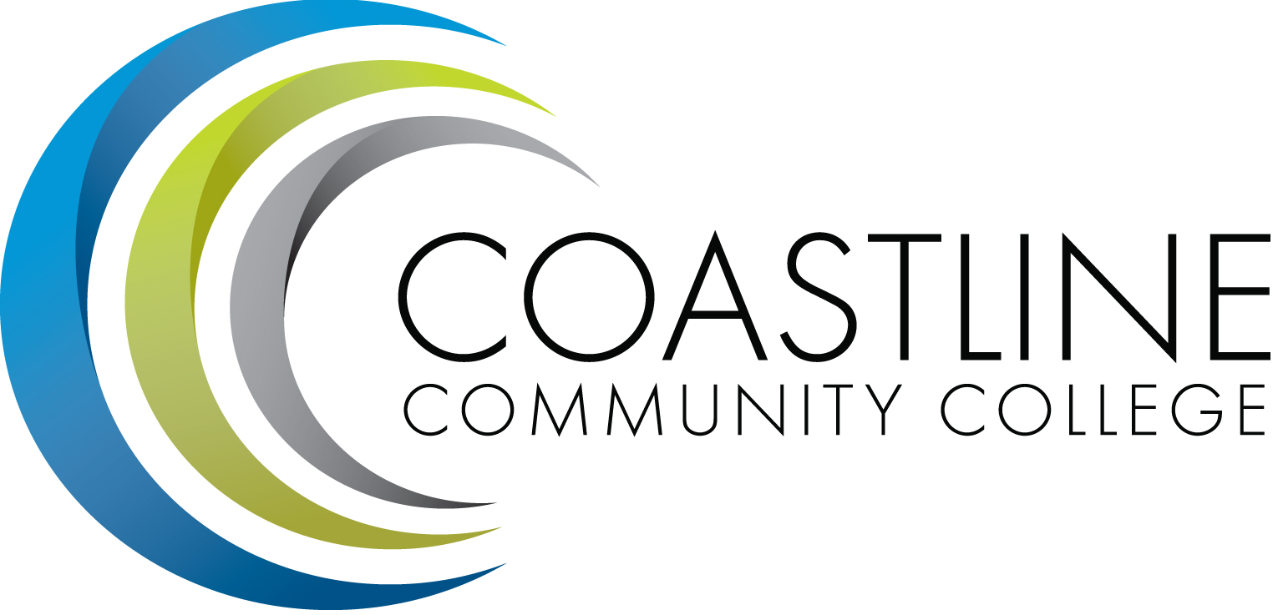

College Professional Development & Leadership Committee Agenda
11/01/2016
3:00 pm to 5:00 pm
College Center, Distance Learning Conference Room

Committee Mandate: To promote, coordinate, recommend, and support the creation and delivery of professional development and leadership programs that increase the effectiveness of our institution and the satisfaction of our employees.
- CALL TO ORDER
  - Roll Call

Present | Members
 | Bob Nash, Co-chair, Associate Dean, Distance Learning & Prof. Development
 | Cheryl Chapman, Co-chair, Academic Senate Representative
 | Mitchell Alves, Faculty Success Center Coordinator
 | Judy Garvey, MECTBD Administrator Representative
 | Elaine Hill, Classified Senate Representative
 | Ken Leighton, Academic Senate Representative
 | Dorothy McCollom, Classified Senate Representative & Committee Support
 | Renate Akins, Director of HR
 | Araba Mensah, Classified Senate Representative
 | Randall Warwick, Academic Senate Representative

  - Welcome
  - Adoption of Agenda
  - Approval of Minutes: 10/04/2016

- SPECIAL REPORTS & UPDATES
  - Demo Cornerstone (Bob Nash/Renate Akins)

- ACTION ITEMS
  - Group will review Summer Institute Survey and propose topics for next year
  - Spring Workshop Date

- STANDING REPORTS
  - None

- DISCUSSION ITEMS
5.1 Creating a New Training Needs Survey for Each Discipline/Department (Bob)

- ANNOUNCEMENTS (1-2 minutes per)
  - 2017 4CSD Annual Conference, March 16 & 17, 2017 (Bob)
  - ITC’s eLearning 2017 Conference, “The Beauty of eLearning”, February 19-22, 2017 (Bob)
  - League of Innovations 19th Annual Innovations Conference, March 12-15, 2017 (Bob)
6.3 Next Meeting, December 6, 2016 at 3:00 pm
- ADJOURNMENT

